**Personalized Parameters (See the Google Sheet below to know your parameters):**

Sheet: [NS2 Parameter Assignment](https://docs.google.com/spreadsheets/d/1CatVDd32LFwTkckVIjVi5agnkFNmuGzGRdyxz46fQMg/edit?usp=sharing)

|  |  |  |  |  |  |
| --- | --- | --- | --- | --- | --- |
| 1605062 | 802.15.4 | AODV | TCP Tahoe + Telnet | Grid | Random Source Destination |

Wireless MAC Type:

* Wireless 802.15.4
* Wireless 802.11

Routing Protocol:

* DSDV
* AODV
* DSR

Agent + Application:

* UDP + Exponential Traffic
* UDP + CBR Traffic
* TCP Reno + FTP
* TCP Tahoe + Telnet,

Node Positioning:

* Random (Randomly place nodes anywhere with area)
* Grid (Place nodes in a grid. You can choose the number of rows and columns yourself)

Flow:

* Random Source Destination (For each flow, choose random source and destination. Careful not to choose same node as source and destination)
* 1 Source, Random Sink (except source itself) (Choose a random source X, then for each flow choose X as source, and any other node as destination)
* 1 Sink, Random Source (Choose a random sink X, then for each flow choose X as destination, and any other node as source)

**Parameters of All:**

Queue: Droptail, max size 50

Antenna: Omni Directional

Speed of nodes: Uniform random between 1m/s and 5m/s for each node.

Propagation Model: Two Ray Ground Propagation Model

With your personalized parameters and global parameters fixed, vary the parameters below.

**Baseline Parameters:** (while varying one parameter, keep other parameters fixed like below)

* Area Size: 500m x 500m
* Number of Nodes: 40
* Number of flows: 20

**Vary parameters:**

* Area Size: 250m x 250m, 500m x 500m, 750m x 750m, 1000m x 1000m, 1250m x 1250m
* Number of Nodes: 20, 40, 60, 80, 100
* Number of flows: 10, 20, 30, 40, 50

**Metrics:**

For each of the varying parameters, plot 4 graph showing,

* Network throughput
* End-to-end delay
* Packet delivery ratio (total # of packets delivered to end destination / total # of packets sent)
* Packet drop ratio (total # of packets dropped / total # of packets sent)

**For example:**

Say, for varying area size. Keep other params fixed as mentioned in baseline. Find 4 metrics for each of the values of area size. Plot each metric in a separate graph. You will get 4 graphs for varying area size. One of them is the Delivery ratio. It may look like this. **Clearly mention the x-axis, y-axis, x-ticks and y-ticks.**

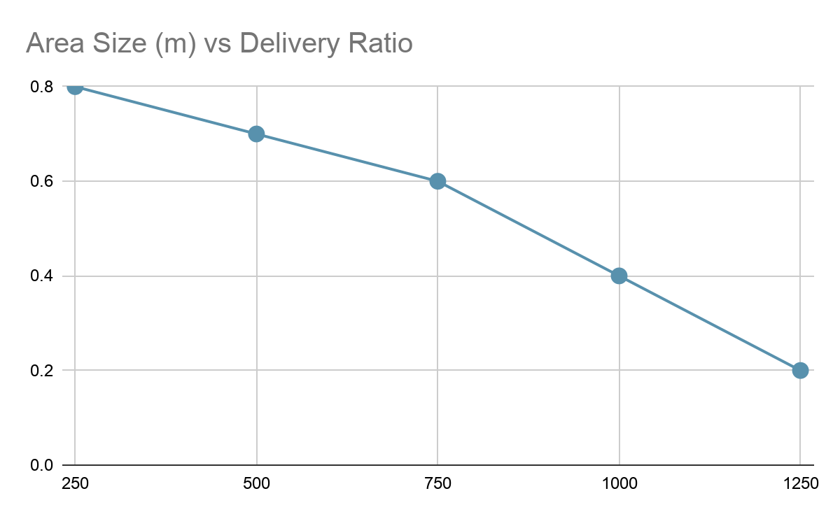

The total number of graphs will be 3 x 4 = 12.

**Report:**

* Write short descriptions of your MAC type, Routing protocol, Agent Type, Application.
* Include all the 12 graphs.
* Write short observations on the results you got.

**Submission:**

* Code (exclude the trace files, nam files). Include only the source files (.tcl, .sh, .awk, .py, .ipynb or others)
* Report as pdf.
* Put all of these in a zip file
* Name it as your student id
* Submit

**Marks:**

|  |  |
| --- | --- |
| Basic Simulation and configs | 4 |
| Vary area size + graph | 4 |
| Vary number of nodes + graph | 4 |
| Vary number of flows + graph | 4 |
| Report | 4 |
| **Total** | **20** |

**Submission Deadline: 19 December Saturday, 8.00am.**

**Appendix A: List of graphs**

|  |  |  |  |  |  |
| --- | --- | --- | --- | --- | --- |
| **Graph No.** | **x-axis** | **y-axis** | **Fixed Param Values** | | |
| **Area-size** | **Number of nodes** | **Number of flows** |
| 1 | Area Size  250m x 250m, 500m x 500m, 750m x 750m, 1000m x 1000m, 1250m x 1250m | Network throughput | - | 40 | 20 |
| 2 | End-to-end Delay | - | 40 | 20 |
| 3 | Packet delivery ratio | - | 40 | 20 |
| 4 | Packet drop ratio | - | 40 | 20 |
| 5 | Number of nodes  20, 40, 60, 80, 100 | Network throughput | 500m x 500m | - | 20 |
| 6 | End-to-end Delay | 500m x 500m | - | 20 |
| 7 | Packet delivery ratio | 500m x 500m | - | 20 |
| 8 | Packet drop ratio | 500m x 500m | - | 20 |
| 9 | Number of flows  10, 20, 30, 40, 50 | Network throughput | 500m x 500m | 40 | - |
| 10 | End-to-end Delay | 500m x 500m | 40 | - |
| 11 | Packet delivery ratio | 500m x 500m | 40 | - |
| 12 | Packet drop ratio | 500m x 500m | 40 | - |